Pupil Premium Strategy Statement – St Anne’s Catholic Primary School
This statement details our school’s use of pupil premium funding to help improve the attainment of our disadvantaged pupils. It outlines our pupil premium strategy, how we intend to spend the funding in this academic year and outcomes for disadvantaged pupils last academic year

School overview
Detail | Data
Number of pupils in school | 240
Proportion (%) of pupil premium eligible pupils | 60%
Academic year/years that our current pupil premium strategy plan covers (3 year plans are recommended) | 2022/2023 to  2024/2025
Date this statement was published | September 2023
Date on which it will be reviewed | July 2024
Statement authorised by | L Prescott Headteacher
Pupil premium lead | L Prescott Headteacher
Governor | Gill Billinge lead for disadvantaged pupils

Funding overview
Detail | Amount
Pupil premium funding allocation this academic year | £183,975
Recovery premium funding allocation this academic year | 0
Pupil premium (and recovery premium) funding carried forward from previous years | 0
Total budget for this academic year | £183,975

Part A: Pupil premium strategy plan

Statement of intent
Our intention is that all pupils, irrespective of their background or the challenges they face, make good progress and achieve high attainment across all subject areas. The focus of our pupil premium strategy is to support disadvantaged pupils to achieve that goal, including progress for those who are already attaining National Expectations We will consider the challenges faced by vulnerable pupils, such as those who have a social worker and young carers. The activity we have outlined in this statement is also intended to support their needs, regardless of whether they are disadvantaged or not. High-quality teaching is at the heart of our approach, with a focus on areas in which disadvantaged pupils require the most support. This is proven to have the greatest impact on closing the disadvantage attainment gap and at the same time will benefit the non-disadvantaged pupils in our school. Implicit in the intended outcomes detailed below, is the intention that non-disadvantaged pupils’ attainment will be sustained and improved alongside progress for their disadvantaged peers.
Our strategy is also integral to wider school plans for education recovery (St Anne’s still is considering the missed learning from the pandemic in this statement). Our approach will be responsive to common challenges and individual needs, rooted in robust diagnostic assessment, not assumptions about the impact of disadvantage. The approaches we have adopted complement each other to help pupils excel. To ensure they are effective we will:
- ensure disadvantaged pupils are challenged in the work that they’re set by adapting our Learning Intentions ·
- act early to intervene when a need is identified ·
- adopt a whole school approach in which all staff take responsibility for disadvantaged pupils’ outcomes and raise expectations of what they can achieve.
The mental health needs of pupils is still a priority and this is supported by the school in a variety of ways, enabling our disadvantaged children to make at least the same progress as all other children. Working through well sequenced, purposeful learning schemes. For example, we now follow pathways to read and Write, which includes a diagnostic assessment tool for tracking children’s progress. In maths, we will utilize the White Rose hub as our spine of learning.
Focus on consolidation of basic skills. The core skills, which enable successful learn-ing, will require increased curriculum time across all year groups. These include: hand-writing, spelling of high frequency words, basic sentence punctuation, phonics, times tables recall, basic addition & subtraction fact recall and reading skills relevant to age. In order to keep a broad and balanced curriculum, some subject areas may be taught as blocked days rather than weekly lessons in the autumn term. Particular focus on early reading and phonics. This is always a focus in the school and will continue to be so in order to develop children’s reading ability and vocabulary. Assessment of learning and of basic skills to identify major gaps. Teachers will work to identify gaps in learning and adapt teaching accordingly. This will be supported by using ‘Balance’ as a planning and assessment tool. Additional time to practice basic skills. This again will be dependent on need of children in order to re-establish good progress in the essentials (phonics and reading, increasing vocabulary, writing and mathematics) and there will be flexibility on timetables to allow this.

Challenges
St Anne’s is in an area of extremely high total deprivation. The total deprivation is made up of key areas which include income, employment, health, crime and living environment. This means that our children face many barriers to educational achievement including:
• limited access to high quality English language
• poor literacy levels
• poor attendance
• low aspirations
• low expectations
• narrow experience of life outside school
This details the key challenges to achievement that we have identified among our disadvantaged pupils.
Challenge number | Detail of challenge
1 | Assessments, observations, and discussions with pupils indicate under-developed oral language skills and vocabulary gaps among many of our disadvantaged pupils. These are evident from Reception through to KS2 and in general, are more prevalent among our disadvantaged pupils than their peers.
2 | Assessments, observations, and discussions with pupils suggest disadvantaged pupils generally have greater difficulties with phonics than their peers. This negatively impacts their development as readers.
3 | Our assessments and observations indicate that the education and wellbeing of many of our disadvantaged pupils have been impacted by partial school closures to a greater extent than for other pupils. These findings are supported by national studies. This has resulted in significant knowledge gaps leading to pupils falling further behind age-related expectations, especially in reading
4 | Our assessments (including wellbeing survey), observations and discussions with pupils and families have identified social and emotional is-sues for many pupils. These challenges particularly affect disadvantaged pupils, including their attainment.
5 | Our attendance data over the last X years indicates that attendance among disadvantaged pupils has been between X - Y% lower than for non-disadvantaged pupils.  X - Y% of disadvantaged pupils have been ‘persistently absent’ compared to X - Y% of their peers during that period. Our assessments and observations indicate that absenteeism is negatively impacting disadvantaged pupils’ progress.

Intended outcomes
This explains the outcomes we are aiming for by the end of our current strategy plan, and how we will measure whether they have been achieved.
Intended outcome | Success criteria
Improved oral  language skills and  vocabulary among  disadvantaged pupils. | Assessments and observations indicate significantly improved oral language among disadvantaged pupils. This is evident when triangulated with other sources of evidence, including engagement in lessons, book scrutiny and ongoing formative assessment
Improved reading attainment among disadvantaged pupils. | KS2 reading outcomes in 2019 show that there was a gap between disadvantaged pupils and met the expected standard.
To achieve and sustain improved wellbeing for all pupils in our school, particularly our disadvantaged pupils. | Sustained high levels of wellbeing demonstrated by: · qualitative data from student voice, student and parent surveys and teacher observations · a significant increase in participation in enrichment activities, particularly among disadvantaged pupils
To achieve and sustain improved attendance and persistence absence for all pupils, particularly our disadvantaged pupils.  On SPP Plan | Sustained high attendance demonstrated by: the overall absence rate for all pupils being no more than 97%, and the attendance gap between disadvantaged pupils and their non-disadvantaged peers being reduced. The percentage of all pupils who are persistently absent being below 10% and the figure among disadvantaged reduces to 0%

Activity in this academic year
This details how we intend to spend our pupil premium funding this academic year to address the challenges listed above.

Teaching (for example, CPD, recruitment and retention)
Budgeted cost: £9,000
Activity | Evidence that supports this approach
Purchase of standardised diagnostic assessments.  Training for staff to ensure assessments are interpreted and administered correctly. | Standardised tests can provide reliable insights into the specific strengths and weaknesses of each pupil to help ensure they receive the correct additional support through interventions or teacher instruction:  Standardised tests | Assessing and Monitoring Pupil Progress | Education Endowment Foundation | EEF
Embedding dialogic activities across the school curriculum. Work with S&L therapist and afternoon intervention from L3 TA These can support pupils to articulate key ideas, consolidate understanding and extend vocabulary.  We will purchase resources and fund ongoing teacher training and release time. | There is a strong evidence base that suggests oral language interventions, including dialogic activities such as high-quality classroom discussion, are inexpensive to implement with high impacts on reading:  Oral language interventions | Toolkit Strand | Education Endowment Foundation | EEF
Secure stronger phonics teaching for all pupils. Embed ‘little wandle’ allocate a phonics champion | Phonics approaches have a strong evidence base that indicates a positive impact on the accuracy of word reading (though not necessarily comprehension), particularly for disadvantaged pupils:  Phonics | Toolkit Strand | Education Endowment Foundation | EEF
Enhancement of our maths teaching and curriculum planning in line with DfE and EEF guidance.  We will fund teacher release time to embed key elements of guidance in school and to access Maths Hub resources and CPD  Enrolled on LA training | The DfE non-statutory guidance has been produced in conjunction with the National Centre for Excellence in the Teaching of Mathematics, drawing on evidence-based approaches:  Maths_guidance_KS_1_and_2.pdf (publishing.service.gov.uk)  The EEF guidance is based on a range of the best available evidence:  Improving Mathematics in Key Stages 2 and 3
Improve the quality of social and emotional (SEL) learning.  SEL approaches will be embedded into routine educational practices and supported by professional development and training for staff. | There is extensive evidence associating childhood social and emotional skills with improved outcomes at school and in later life (e.g., improved academic performance, attitudes, behaviour and relationships with peers):  EEF_Social_and_Emotional_Learning.pdf(educationendowmentfoundation.org.uk)

Targeted academic support
Budgeted cost: £96,275
Activity | Evidence that supports this approach
To fund full time TAs  within each class who  can support learning and  target PP children in the  morning and through  appropriate interventions  in the afternoon working  on OSPs (1:1 or small  group) | Accelerated progress of PP children and non-PP children leading to improved outcomes across the whole school Barriers to be addressed: limited access to high quality English language poor literacy levels low expectation
Additional phonics sessions targeted at disadvantaged pupils who require further phonics support. This will be delivered in collaboration with our local English hub. | Phonics approaches have a strong evidence base indicating a positive impact on pupils, particularly from disadvantaged backgrounds. Targeted phonics interventions have been shown to be more effective when delivered as regular sessions over a period up to 12 weeks:  Phonics | Toolkit Strand | Education Endowment Foundation | EEF
Talk about Town  Ed Psyche Assessments  Ed Psych Therapy  Now have a TA doing 1:1  S&L therapy each  afternoon | Accelerate diagnosis and make statutory referrals for funding etc Full day provision of high quality therapy working directly with the children and parents of our most vulnerable families. Having a huge benefit both with practical issues, behaviour and mental health
To subsidise the school  residential so it is financially accessible to lower-income families  To subsidise the cost of  educational visits | Children develop skills of independence, resilience and responsibility and have more opportunities so that they have a greater wealth of experiences about which to write and talk Barriers to be addressed: • limited access to high quality English language • poor attendance narrow experience of life outside school
S&L therapy intervention throughout school delivered by TA, planned by private S&L therapist | There is a strong evidence base that suggests oral language interventions, including dialogic activities such as high-quality classroom discussion, are inexpensive to implement with high impacts on reading:

Wider strategies (for example, related to attendance, behaviour, wellbeing)
Budgeted cost: £78,700
Activity | Evidence that supports this approach
Whole staff training on behaviour management using the kindness principles approaches with the aim of developing our school ethos and improving behaviour across school.  Trauma Training NLE | Both targeted interventions and universal approaches can have positive overall effects:  Behaviour interventions | EEF (educationendowmentfoundation.org.uk)
Embedding principles of good practice set out in the DfE’s Improving School Attendance advice.  This will involve training and release time for staff to develop and implement new procedures and appointing attendance/support officers to improve attendance.  Attendance is now part of the staff Appraisal process  FPW is on the door from 9:00am to speak to any families that are late and find solutions to any immediate issues. | The DfE guidance has been informed by engagement with schools that have significantly reduced levels of absence and persistent absence.
ELSA qualified TA  TA running SEMH interventions every afternoons for those pupils not yet ready to learn.  Ready to Learn areas in every classroom – zones of regulation | Running our Rainbows (Nurture) room in the morning and sessions every afternoon both timetabled and drop in sessions when needed  Helping return children to class quickly
FT Family Partnership worker | Working with families in social care and individual children highlighted as concerns in school 1:1 and small groups
School Counsellor  EP family therapy – working with parents and children | Parents to be supportive of school and help their children to develop the skills of good citizens  Barriers to be addressed:  poor attendance  low aspirations  low expectations narrow experience of life outside school
To fund school uniform and  milk for eligible children | Children to be proud to be one of the St  Anne’s team
Contingency fund for acute issues. | Based on our experiences and those of similar schools to ours, we have identified a need to set a small amount of funding aside to respond quickly to needs that have not yet been identified.eg alternative provision
Educational Phycologist | After assessments then does follow up therapy work with the family
Internal Inclusion base (Rainbows) | For a small group of children who are not accessing their learning despite support and our Ready to Learn areas.

Total budgeted cost: £ 183,975

Part B: Review of the previous academic year

Outcomes for disadvantaged pupils
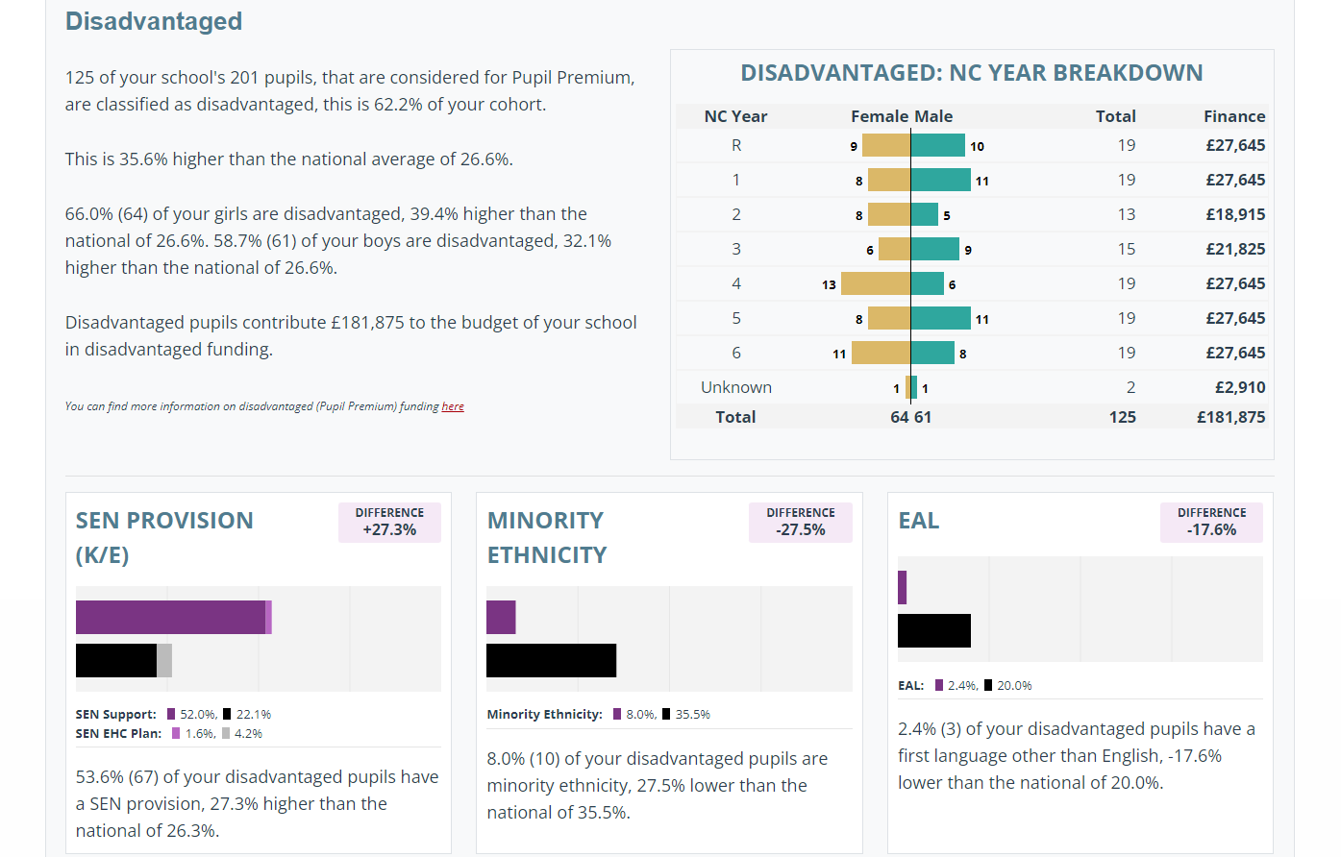

Externally provided programmes
Programme | Provider
School councillor | Brighter Horizons
ELSA Teacher | Trained through LA
ADHD Foundation therapist | ADHD Foundation
S&L Therapist | Talk about Town
Trauma Informed school with 2 qualified members of staff, one being the DHT who is also our mental health lead. | DfE funded
Mental Health Team | NHS Wirral
Behaviour Hub Partner school | DfE
Educational Phycologist | Beth Sheldrake (Private)

