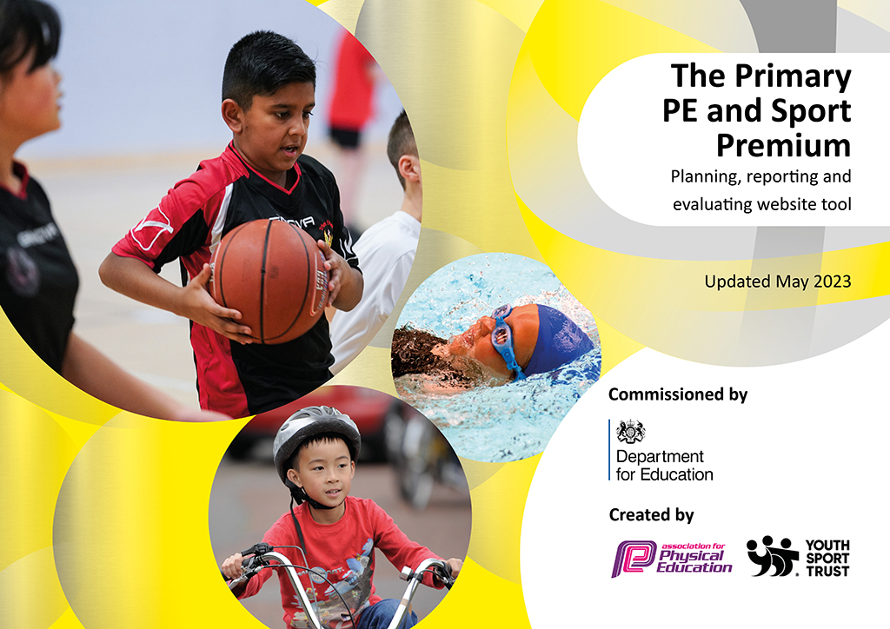
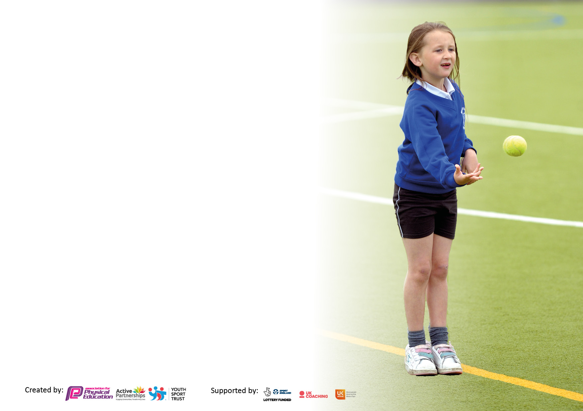

It is important that your grant is used effectively and based on school need. The Education Inspection Framework makes clear there will be a focus on ‘whether leaders and those responsible for governors all understand their respective roles and perform these in a way that enhances the effectiveness of the school’.

Under the Quality of Education Ofsted inspectors consider:
Intent - Curriculum design, coverage and appropriateness
Implementation - Curriculum delivery, Teaching (pedagogy) and Assessment
Impact - Attainment and progress

To assist schools with common transferable language this template has been developed to utilise the same three headings which should make your plans easily transferable between working documents.

Schools must use the funding to make additional and sustainable improvements to the quality of Physical Education, School Sport and Physical Activity (PESSPA) they offer. This means that you should use the Primary PE and sport premium to:

- Develop or add to the PESSPA activities that your school already offer
- Build capacity and capability within the school to ensure that improvements made now will benefit pupils joining the school in future years
- The Primary PE and sport premium should not be used to fund capital spend projects; the school’s budget should fund these.

Pleasevisitgov.ukfortherevisedDfEguidanceincludingthe5keyindicatorsacrosswhichschoolsshoulddemonstrate animprovement.Thisdocumentwillhelpyoutoreviewyourprovisionandtoreportyourspend.DfEencouragesschools to use this template as an effective way of meeting the reporting requirements of the Primary PE and Sport Premium.

We recommend you start by reflecting on the impact of current provision and reviewing the previous spend.

Schools are required to publish details of how they spend this funding, including any under-spend from 2021/2022, as well as on the impact it has on pupils’ PE and sport participation and attainment. All funding must be spent by 31st July 2023.

We recommend regularly updating the table and publishing it on your website throughout the year. This evidences your ongoing self-evaluation of how you are using the funding to secure maximum, sustainable impact. Final copy must be posted on your website by the end of the academic year and no later than the 31st July 2023. To see an example of how to complete the table please click HERE.

Details with regard to funding
Please complete the table below.

Total amount carried over from 2021/22 | £11981.26
Total amount allocated for 2021/22 | £17765.00
How much (if any) do you intend to carry over from this total fund into 2022/23? | £0
Total amount allocated for 2022/23 | £17710
Total amount of funding for 2023/23. To be spent and reported on by 31st July 2023. | £ 17710
Swimming Data
Please report on your Swimming Data below.

Meeting national curriculum requirements for swimming and water safety.  N.B. Complete this section to your best ability. For example you might have practised safe self-rescue techniques on dry land which you can then transfer to the pool when school swimming restarts.  Due to exceptional circumstances priority should be given to ensuring that pupils can perform safe self rescue even if they do not fully meet the first two requirements of the NC programme of study | 33%
What percentage of your current Year 6 cohort swim competently, confidently and proficiently over a distance of at least 25 metres?  N.B. Even though your pupils may swim in another year please report on their attainment on leaving primary school at the end of the summer term 2022.  Please see note above | 45%
What percentage of your current Year 6 cohort use a range of strokes effectively [for example, front crawl, backstroke and breaststroke]?  Please see note above | 55%
What percentage of your current Year 6 cohort perform safe self-rescue in different water-based situations? | 33%
Schools can choose to use the Primary PE and sport premium to provide additional provision for swimming but this must be for activity over and above the national curriculum requirements. Have you used it in this way? | No

Action Plan and Budget Tracking
Capture your intended annual spend against the 5 key indicators. Clarify the success criteria and evidence of impact that you intend to measure to evaluate for pupils today and for the future.

Academic Year: 2022/23 | Total fund allocated: | Date Updated:
Key indicator 1: The engagement of all pupils in regular physical activity – Chief Medical Officers guidelines recommend that primary school pupils undertake at least 30 minutes of physical activity a day in school |  |  |  | Percentage of total allocation:
 |  |  |  | 26%
Intent | Implementation |  | Impact
Your school focus should be clear what you want the pupils to know and be able to do and about  what they need to learn and to  consolidate through practice: | Make sure your actions to achieve are linked to your intentions: | Funding allocated: | Evidence of impact: what do pupils now know and what can they now do? What has changed?: | Sustainability and suggested next steps:
To ensure children are meeting the active 30 minutes each day.  To support children to further develop physical literacy, fundamental movement skills and gross motor skills across EYFS and Key Stage 1. | Edsential Play Maker Award:  - Year 5/6 children to take part in the Play Maker Award programme to develop leadership and communication skills, alongside supporting the delivery of active playtimes.  - PE Lead to oversee the planning and delivery of a range of structured physical (traditional and non-traditional) activities on different playgrounds, led by young leaders.  Change to lunchtime schedule to support all children across KS2 to meet the active 30 minutes.  - 20 minutes of physical activity for each year group, every day.  Extra-Curricular ‘Sports’ Clubs:  - - Extra-Curricular clubs offered to all children free of charge to support them achieving the 30 minutes of physical activity each day. | £700  £2241.67  Dance - £660  Monday - £1000 | Edsential Impact report provided:  View the impact for this programme here.  % of pupil engaged in structured activity at lunch times:  EYFS =  Key Stage 1 = 71%  Key Stage 2 = 100%  Playground equipment  % of children attending at least one club:  46.8% of children from KS1  65% % of children from KS2  Compared to 2021-22:  - KS1 – 59%  - KS2 - 54% | Year 5 children to take over leadership roles from September 23.  Local SGOs to support with this throughout the year.  20-20-20 cycle for lunch times to continue for 23-24.  Wide range of sporting activities offered to support children in meeting the active 30 minutes to continue.
Key indicator 2: The profile of PESSPA being raised across the school as a tool for whole school improvement |  |  |  | Percentage of total allocation:
 |  |  |  | 47%
Intent | Implementation |  | Impact
Your school focus should be clear what you want the pupils to know and be able to do and about  what they need to learn and to  consolidate through practice: | Make sure your actions to achieve are linked to your intentions: | Funding allocated: | Evidence of impact: what do pupils now know and what can they now do? What has changed?: | Sustainability and suggested next steps:
We aim to use the power of PE, School Sport and Physical Activity to increase:  - Support Healthy Lifestyles  - Social interaction/ Social skills  - Physical literacy/ gross motor skills  - Engagement in daily activity | Edsential PE Subject Leader (A. Barnes)  - PE Subject Leader purchased through Edsential  Learning Outside the Classroom Extra-Curricular Clubs | £4,985  £3,300 | Duties include but not limited to:  - Overseeing curriculum PE (curriculum design, planning, assessment, monitoring)  - Provide ongoing CPD for teaching staff, through team-teaching, staff meetings and ongoing advice.  - Arranging afterschool clubs, competitions and events, including Sports Days.  - Organising school swimming  PE Curriculum now focused around 4 key areas:  - Physical Competence  - Decision Making  - Social skills  - Healthy Lifestyles knowledge  Additional Learning Outside the Classroom clubs purchased to further support the development of:  - Social skills/ interaction  - Teamwork  - Communication skill  - Resilience | PE Subject Leader to continue in role for 23-24.  PE curriculum to function in a similar way to 22-23, with a greater focus on assessment and how this can impact teaching and learning.  Learning Outside the Classroom will not continue for 23-24.

Key indicator 3: Increased confidence, knowledge and skills of all staff in teaching PE and sport |  |  |  | Percentage of total allocation:
 |  |  |  | 2%
Intent | Implementation |  | Impact
Your school focus should be clear | Make sure your actions to | Funding | Evidence of impact: what do | Sustainability and suggested
what you want the pupils to know | achieve are linked to your | allocated: | pupils now know and what | next steps:
and be able to do and about | intentions: |  | can they now do? What has
what they need to learn and to |  |  | changed?:
consolidate through practice:
To improve the quality of PE teaching across school. | 12-month subscription to the Edsential PE Scheme of Work – Total PE+  Curriculum Support (CPD)  - PE Subject Leader delivered 12-weeks of PE CPD for school staff. | £300  See KI2 | All school staff are now using this for individual lesson plans to support teaching and learning.  - Staff reported increase in confidence teaching PE – Staff audit of subject knowledge.  - Curriculum PE Assessments now show an improvement in the number of children meeting | Total PE+ subscription renewed to continue to support school teaching staff.
Key indicator 4: Broader experience of a range of sports and activities offered to all pupils |  |  |  | Percentage of total allocation:
 |  |  |  | 25%
Intent | Implementation |  | Impact
Your school focus should be clear | Make sure your actions to | Funding | Evidence of impact: what do | Sustainability and suggested
what you want the pupils to know | achieve are linked to your | allocated: | pupils now know and what | next steps:
and be able to do and about | intentions: |  | can they now do? What has
what they need to learn and to |  |  | changed?:
consolidate through practice:
To use a wider range of physical activities and sports to promote healthy lifestyles. | Extra-Curricular clubs used to increase range of activities offered to children.  HYPE – Balance Bikes  - Weekly ‘balance bike’ sessions for all children within EYFS.  - Aimed at promoting active travel to our youngest children.  - Aimed also at supporting gross-motor skill development within Early Years. | See KI2  £4500 | 13 different sports covered through our extra-curricular offer to children, compared to 11 different activities offered across 2021/22.  Activities selected based on easily-accessible activities in the local area and building partnerships with local providers to increase engagement outside of school hours:  Football, Dance, Tennis, Cricket, Athletics.  All children within EYFS have accessed weekly ‘Balance Bike’ sessions.  This had led to an increased number of children meeting physical ELGs, compared to 21/22, in addition to:  - Increased Balance,  - Increased gross-motor skills development,  - increased confidence and resilience. | Wide range of sporting activities offered to support children to find ‘their’ sport and continue to engage in competitions and events, which in turn is supporting participation outside of school hours.  Hype Balance Bikes will not continue for 23-24.  Bike-ability to instead be utilised to support KS2 children.

Key indicator 5: Increased participation in competitive sport |  |  |  | Percentage of total allocation:
 |  |  |  | %
Intent | Implementation |  | Impact
Your school focus should be clear | Make sure your actions to | Funding | Evidence of impact: what do | Sustainability and suggested
what you want the pupils to know | achieve are linked to your | allocated: | pupils now know and what | next steps:
and be able to do and about | intentions: |  | can they now do? What has
what they need to learn and to |  |  | changed?:
consolidate through practice:
To use sporting events and competitions to raise aspirations and engagement with the range of opportunities on offer within our local community.  To use sporting events and competitions to increase interaction with local members of the community, support transition to high school and build relationships with local providers. | Access to Edsential ‘Competitions for All’ Programme:  - Weekly competitions programme aimed at engaging all children with competitive sport.  Hire of local sports hall to allow us to host competitions. | Included as part of Edsential Subject Leadership.  £321.00 | Number of sporting events attended:  2023 – 24- 6  2022 – 23 - 8  2021-22 - 3  % of children who took part in a competition or event this year:  - EYFS –0%  - KS1 – 0%  - KS2 – 19%  All children from Key Stage 2 took part in our Sports Day, held at our local athletics stadium.  This was done to build familiarity and relationships, with the aim of encouraging children to become members. | Access to Edsential ‘Competitions for All’ programme will continue again for 23-24.  Our aim is to further increase the number of events we attend.  Greater focus on all extra-curricular clubs ‘leading up to’ an event, competition or celebration of achievement.  Engagement of EYFS and KS1 into our competitions programme also to be a key area for development.

Signed off by
Head Teacher: | Lorraine Prescott
Date: | May 2023
Subject Leader: | Alex Barnes
Date: | May 2023
Governor: | Mary Tyrrell
Date: | May 2023

Spending Overview for 2022-23:
Income though the PE and Sport Premium for 2022-23: £17,710
Product/ Service | Cost
Edsential PE Subject Leadership | £4985
Edsential PE Scheme of Work – Total PE+ | £300
Edsential PlayMaker Award | £700
Dance ASC | £300 (Spring 1) and £360 (Summer 1)
Play equipment | £1920.67
Sports Day 2022/23 | £321.00
Monday Afterschool Club (Autumn 1 – Summer 2) | £1000
Learning Outside the Classroom After school club x 2  (Autumn 1 – Summer 2) | £3,323.33
Hype - Balance Bikes and After school club (Autumn 1 – Summer 2) | £4500
Total Cost: | £17,710

